Author: Adam Smith
System: HTC Vive
Platform: Unity 5.5.3f

Victim Health Monitor
This script is simple to implement and add in project, Just drag and drop as seen in the Youtube video. This script is placed on the player.
Below is an example of what the script will look like once it is Added and what components / gameobjects need to be added. The script is labled VICTIM HEALTH MONITOR ( SCRIPT)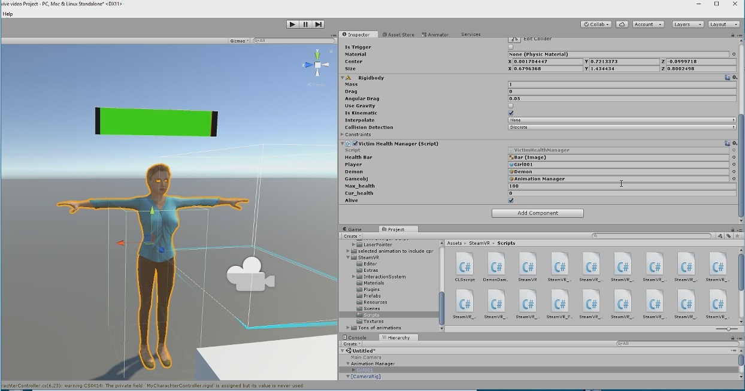
Components added
- Assuming you have created a health bar before, The Health Bar component, for full health is added in the Health bar window.
- Next is player this script is attached to
- Third is the gameobject inflicting the damage
- Max health is auto set and so is cur_health
- Last is the bool set at alive for the player, so that once the player dies that can be identified.

The DemonDamager script

This script is simple added to the GameObject inflicting damage
For collision add box collider

CLSscript

This script is simple added to controllers

For collision add box collider

